**GROUP 23**

**Labadan,Miko** – Researcher

**Madridano, Gabriel Paolo –** System Analyst

**Nacaya, Michael** - Developer

**Pagaling, Sandara Jane** – Project Manager

**Ragasi, Brian** - Developer

**Salaysay, Jasmin** – Reseacher

**Introduction**

Our client owns a bakery and is seeking to establish a comprehensive online presence to better reach and serve her customers. While social media platforms are effective for engaging with customers and marketing products, they do not fully meet the needs of a modern bakery business. Therefore, our team proposes to develop a dedicated bakery website that complements social media efforts. This website will allow customers to view and order products online, offering features such as a customer dashboard and an admin dashboard for effective business management.

**Statement of the Problem**

The client, a bakery owner, currently relies solely on social media for her online presence, which limits her ability to fully manage her business and provide a seamless customer experience. Social media platforms, while beneficial for marketing and customer engagement, **lack the control, customization, and functionality** offered by a dedicated website. Without a website, potential customers cannot easily browse or order products online, reducing the bakery's competitiveness in the digital marketplace. The current setup also makes it challenging for the client to efficiently manage orders and customer interactions.

This project aims to address these issues by developing the **"BakeEase Bakery Website and Management System."** This comprehensive online platform will not only showcase the bakery's products but also provide essential features such as:

1. **Online Ordering System**: Customers can conveniently browse products, add them to a cart, and place orders directly through the website.
2. **Customer Dashboard:** Users can create accounts, track their order history, and manage their profiles.
3. **Admin Dashboard:** The client will have access to a dedicated dashboard to manage products, update inventory, process orders, track customer data, and monitor sales.
4. **Loyalty Program Integration:** A built-in loyalty point system will encourage repeat business and reward loyal customers.

**Expected Outcomes**

By implementing the "BakeEase Bakery Website and Management System," the client is expected to achieve significant improvements across various aspects of her business. The system will enhance business operations by streamlining order management, improving inventory control, and providing valuable insights into customer behavior. Furthermore, it will expand customer reach by increasing online visibility and offering a user-friendly platform for online ordering.

This, in turn, is expected to increase sales and revenue by providing a convenient purchasing method for customers, potentially leading to higher order volumes. Ultimately, the system will improve the overall customer experience by providing a seamless and professional online interaction, fostering customer loyalty and satisfaction. The "BakeEase Bakery Website and Management System" will serve as a centralized hub for all these activities, empowering the client to efficiently manage her bakery, grow her customer base, and ultimately enhance her overall business performance.

**GROUP BIBLE**

The BakeEase project aims to empower BakeEase Bakery with a user-friendly website and management system, enhancing its online presence and streamlining its operations. Developed by a skilled and collaborative team (Group 23), the website will enable customers to easily browse products, place orders online, and manage their accounts through a dedicated customer dashboard. The bakery owner will benefit from an intuitive admin dashboard to efficiently manage products, orders, and customer interactions. The project focuses on creating a seamless and engaging online experience for customers while providing the bakery with the tools to effectively manage and grow its business.

**Core Values**

**Collaboration:** We believe in teamwork, open communication, and mutual support to achieve shared goals.

**Commitment:** We are dedicated to delivering a high-quality product and meeting project deadlines.

**Respect:** We value each team member's contributions, opinions, and time.

**Accountability:** We take responsibility for our actions and strive for continuous improvement.

**Integrity:** We adhere to ethical principles and maintain transparency in our work.

**Team Guidelines**

**Communication & Progress:**

Daily Updates: All team members must provide a brief progress update at the end of each workday via Trello.

Timely Communication: Any anticipated delays or roadblocks must be communicated to the Project Manager immediately.

Open Dialogue: Team members are encouraged to voice concerns, suggestions, or feedback during regular check-in meetings.

Consequences:

Failure to provide daily updates or communicate delays without valid reasons may result in a verbal warning.

Repeated instances of poor communication may lead to a formal warning and potential re-evaluation of responsibilities.

**Collaboration & Support:**

Mutual Assistance: Team members are encouraged to assist each other with tasks when possible, fostering a collaborative environment.

Flexibility & Adaptability: While roles are defined, flexibility is expected. Team members should be willing to assist in areas outside their primary responsibilities as needed.

**Consequences:**

Lack of cooperation or unwillingness to assist team members may result in a verbal warning and a discussion on improving teamwork.

**Work Ethic & Quality:**

Deadlines & Quality: Deadlines are crucial and should be met without compromising the quality of work.

Documentation: Proper documentation of work processes, decisions, and code is essential for project continuity.

Quality Assurance: Regular QA checks will be conducted, and identified issues must be addressed promptly.

**Consequences:**

Failure to meet deadlines or consistently delivering subpar work may result in a formal warning and potential re-evaluation of tasks.

Inadequate documentation may lead to a verbal warning and a request for immediate improvement.

**Rest & Wellbeing:**

Sunday Rest: Team members are encouraged to rest on Sundays unless an urgent and critical issue arises.

Work-Life Balance: Team members who complete tasks ahead of schedule while maintaining quality can take additional time for rest or focus on other project areas.

**Consequences:**

Consistent disregard for rest and wellbeing guidelines may lead to a discussion with the Project Manager to address workload and ensure a sustainable work-life balance.

**Continuous Improvement:**

Process Optimization: Team members should seek ways to improve processes, tools, or techniques.

Reflection & Feedback: Regular reflection meetings will be held to identify areas for enhancement and celebrate successes.

## **Project Requirement Document**

**1.1 Overview:**

BakeEase is a comprehensive online platform designed to enhance the online presence and operational efficiency of BakeEase Bakery. It provides a user-friendly website for customers to browse products, place orders, and manage their accounts. It also includes a dedicated admin dashboard for the bakery owner to manage products, orders, customer interactions, and other essential business operations.

**1.2. Goals:**

Enhance Customer Experience: Provide a seamless and enjoyable online experience for customers to browse products, place orders, and interact with the bakery.

Streamline Business Operations: Empower the bakery owner with an intuitive admin dashboard to efficiently manage products, inventory, orders, and customer data.

Increase Sales and Reach: Expand the bakery's customer base and drive sales through increased online visibility and a convenient online ordering system.

**2. Functional Requirements**

2.1. **Customer-Facing Features:**

Product Gallery:

Display a visually appealing gallery of baked goods, showcasing images, descriptions, prices, and availability status.

Allow customers to filter products by category (e.g., cakes, cookies, pastries).

Online Ordering:

Enable customers to add products to a shopping cart.

Provide cart management features (review, update quantities, remove items).

Calculate the total order cost, including taxes and shipping fees (if applicable).

Allow customers to enter delivery details and choose a payment method.

User Accounts:

Enable customers to create accounts using email addresses.

Allow secure login using email and password.

Provide password recovery functionality.

Offer a customer dashboard to view order history, manage profile details, and track loyalty points.

Customer Reviews:

Allow customers to leave reviews and ratings for purchased products.

**2.2. Admin Features:**

Admin Dashboard: Provide a centralized dashboard for the bakery owner to access all administrative functions.

**Product Management:**

Enable the admin to add, update, and remove products.

Allow bulk upload or editing of products.

Manage product categories and inventory levels.

**Order Management:**

Provide an overview of all orders.

Enable order processing, status updates (e.g., pending, processing, shipped, delivered), and tracking.

Handle order cancellations and refunds.

**Customer Management:**

Access customer data (contact details, order history).

Manage customer accounts and loyalty points.

Respond to customer queries.

**Review Management:**

Moderate customer reviews, approving or rejecting them.

Respond to customer feedback.

**2.3. Payment Processing:**

Secure Payment Gateway Integration: Integrate with a secure payment gateway (e.g., PayPal,) to process online payments.

Order Confirmation and Receipts: Automatically confirm orders upon successful payment and send email receipts to customers.

**2.4. Loyalty Program:**

Points-Based System: Implement a loyalty program where customers earn points for purchases.

Point Redemption: Allow customers to redeem points for discounts on future orders.

**Non-Functional Requirements**

**3.1. Performance:**

Fast Loading Times: The website should load within 3 seconds on a standard broadband connection.

High Concurrency: The system should handle up to 500 concurrent users without performance degradation.

**3.2. Security:**

Secure Data Transmission: Implement SSL encryption to secure all data transmitted between the website and users.

Data Protection: Ensure secure storage of customer data, particularly sensitive information like payment details and addresses, following industry best practices and relevant regulations.

Regular Security Updates: Regularly update and patch the system to prevent security vulnerabilities and protect against potential threats.

**3.3. Scalability:**

Traffic Handling: The system should be scalable to accommodate increasing user traffic and order volumes as the bakery's online business grows.

Cloud Infrastructure: Consider using cloud services (e.g., AWS, Azure) to facilitate easy scaling of the application and resources as needed.

**3.4. Usability:**

Intuitive Navigation: The website should be intuitive and easy to navigate for users of all technical skill levels.

Responsive Design: Implement a responsive design approach to ensure the website is accessible and visually appealing on various devices, including desktops, laptops, tablets, and mobile phones.

**3.5. Cross-Browser Compatibility:**

Browser Support: The website should function correctly and consistently on all major web browsers, including Chrome, Firefox, Safari, and Edge.

**3.6. Accessibility:**

Accessibility Standards: The website should be designed and developed following accessibility guidelines (e.g., WCAG) to ensure inclusivity and usability for people with disabilities.

**USER STORIES**

**Browsing the Product Gallery:**

As a customer, I want to easily browse a visually appealing gallery of baked goods so I can see what's available, check prices, and make informed purchase decisions.

The gallery should display high-quality product images.

Each product listing includes a clear description, price, and availability status.

**Managing My Cart and Ordering Online:**

As a customer, I want to add items to my cart, adjust quantities, and easily place an order online for a convenient shopping experience.

I can add products to my cart directly from the product gallery.

I can view and manage the contents of my cart, including updating quantities and removing items.

The checkout process is straightforward, allowing me to enter delivery details and select a payment method.

I receive order confirmation and a receipt via email.

**Creating and Managing My Account:**

As a customer, I want to create an account to streamline my ordering process, track my order history, and benefit from loyalty programs.

I can create an account using my email address and a secure password.

I can log in to my account to view past orders and manage my profile.

If I forget my password, I can easily recover it.

**Viewing My Order History:**

As a registered customer, I want to access my order history to track the status of my orders and view details of previous purchases.

My account dashboard provides a clear and organized view of my order history.

I can see the status of each order (e.g., pending, processing, shipped, delivered).

I can access order details, including purchased items, delivery information, and total price.

**Redeeming Loyalty Points:**

As a loyal customer, I want to earn points for my purchases and redeem them for discounts on future orders.

The system automatically awards loyalty points for every purchase I make.

I can view my current points balance in my account.

During checkout, I can choose to redeem my points for a discount on my order.

**Contacting the Bakery:**

As a customer, I want to easily find the bakery's contact information to ask questions, provide feedback, or make special requests.

The website includes a dedicated "Contact Us" page with a contact form.

The bakery's phone number, email address, and physical address (if applicable) are clearly displayed.

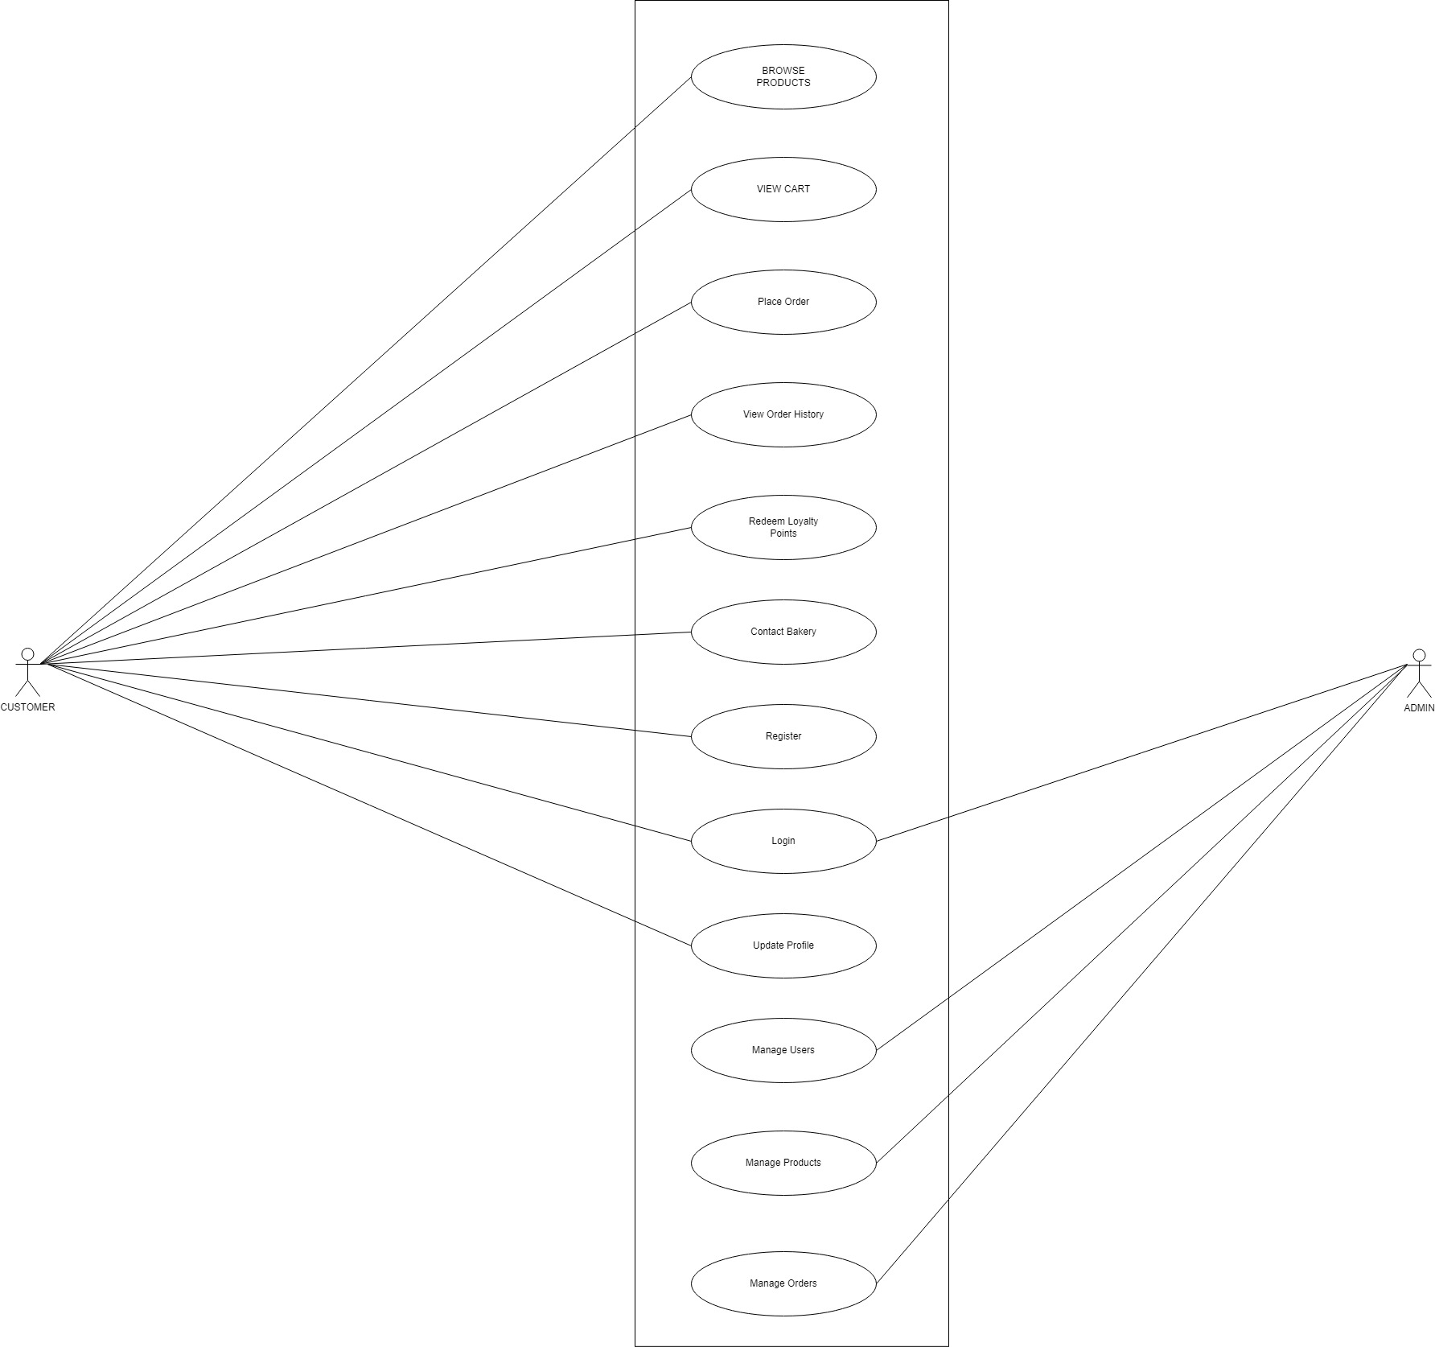**USE CASE DIAGRAM**

**Entity Relationship Diagram**

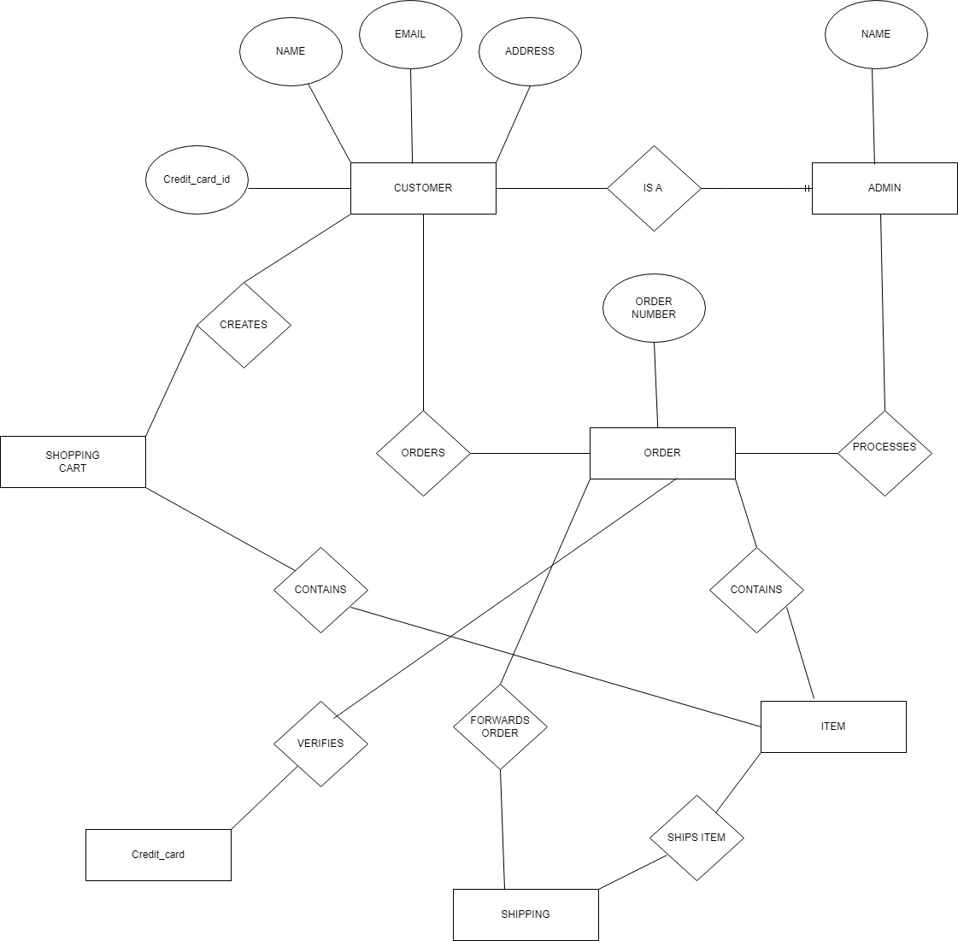

**System Requirement**

**Functional Requirements**

1. **Responsive Design**

Ensure the website works well and looks good on all devices, such as phones, tablets, and desktops.

1. **E-commerce Services**

Implement shopping carts, secure payments, and a way for customers to track their orders.

1. **Product Resources**

Display products with high-quality images, descriptions, and prices. Include search and filtering options.

1. **Customer Reviews**

Allow customers to leave reviews, which are visible to other users.

1. **Account Management**

Enable customers to create accounts to store their information, view pre-packaged packages, and manage personal information.

1. **Loyalty Programs**

Set up rewards programs for repeat customers to earn points or discounts.

1. **Contact Information**

Provide a contact form, along with the bakery’s phone number, email address, and location on a map.

**Non-Functional Requirements**

1. **Performance**

The website should load quickly and handle a high volume of users simultaneously, especially during busy times.

1. **Security**

Use SSL certificates, secure the site with regular updates, and ensure compliance with data protection regulations.

1. **Usability**

The site should be accessible with clear buttons and instructions for users

**Language and Framework**

For developing the BakeEase bakery website, we have chosen **HTML, CSS, JavaScript, and PHP** as our primary technologies due to their versatility and widespread use in web development. HTML (HyperText Markup Language) and CSS (Cascading Style Sheets) are fundamental for creating a structured and visually appealing front-end. They enable us to design a user-friendly interface that is both responsive and aesthetically pleasing across various devices. JavaScript enhances interactivity and dynamic content on the client side, providing a smooth and engaging user experience. PHP (Hypertext Preprocessor) is selected for server-side scripting because of its strong integration with web servers and databases, allowing for efficient handling of backend operations such as user authentication, order processing, and data management. Additionally, PHP's compatibility with MySQL, our chosen database management system, ensures reliable and efficient data storage and retrieval.

To organize and streamline the development process, we have chosen the **Laravel framework** for the backend. Laravel is renowned for its robustness, modern features, and elegant syntax. It offers built-in tools for routing, authentication, and database management, which simplify development and enhance security. Laravel's support for the MVC (Model-View-Controller) architecture helps maintain a clear separation between business logic and user interface, facilitating a more organized and scalable codebase. The combination of these technologies ensures that our bakery website will be efficient, secure, and easy to maintain, providing a seamless experience for both the bakery owner and customers.

**Language and Framework**

For developing the BakeEase Bakery Website and Management System, we have chosen **HTML, CSS, JavaScript, and PHP** as our primary technologies due to their versatility and widespread use in web development. HTML (HyperText Markup Language) and CSS (Cascading Style Sheets) are fundamental for creating a structured and visually appealing front-end. They enable us to design a user-friendly interface that is both responsive and aesthetically pleasing across various devices.

JavaScript enhances interactivity and dynamic content on the client side, providing a smooth and engaging user experience. PHP (Hypertext Preprocessor) is selected for server-side scripting because of its strong integration with web servers and databases, allowing for efficient handling of backend operations such as user authentication, order processing, and data management. Additionally, PHP's compatibility with MySQL, our chosen database management system, ensures reliable and efficient data storage and retrieval.